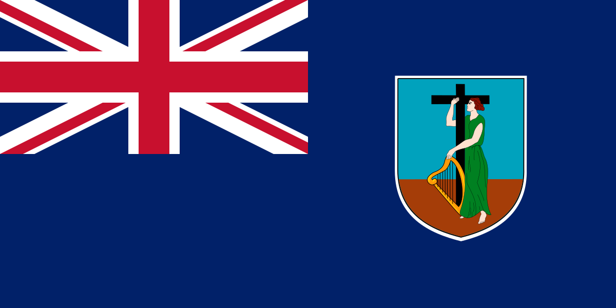
Government of Montserrat
APPLICATION FORM
COVID-Related Financial Support
Support for Businesses Affected by COVID-19
Eligible privately-owned businesses can apply for monthly Financial Support.
Support is available to owners of companies and sole proprietorships who can adequately demonstrate financial difficulty as a result of COVID-19.

Please state below the names and addresses of full-time employees on whom you have based your claim for Financial Support
Emp No. | Employee Name | Address | Gross Average Monthly Salary (six months)
 | Please add additional lines as necessary

