Community Notice
PUBLIC INPUT REQUIRED

The Physical Planning Unit (PPU) within the Ministry of Agriculture, Lands, Housing and the Environment (MALHE), has received an application from Paradise Development Company for a subdivision of Twenty-One (21) lots in Woodlands at Block/Parcel 12/1/207. The subdivision would be conducted in three phases: See Figure 1 attached.

In keeping with Section 16 of the Physical Planning Act which guides the process for Notification before determination of application for development permission, The Planning and Development Authority is hereby seeking comments on the proposal. All comments on the proposal should be received no later than 4.00 p.m., on Monday 22nd August 2022.

All comments are to be addressed to the Chairman, Planning & Development Authority

Attention: Clement Meade
Chief Physical Planner
Physical Planning Unit
Ministry of Agriculture, Trade, Lands, Housing and the Environment
Brades
Montserrat

Telephone: 664-491-6795
Email: ppu@gov.ms

The PPU has published the information at the following:

- On site at Block/Parcel 12/1/207
- The Montserrat Public Library
- The Government of Montserrat website: www.gov.ms
- Zjb Radio
- Physical Planning Unit website: ppu.gov.ms

Figure 1 Ghauts as buffer zones
Residentail lots –parcels 12/1
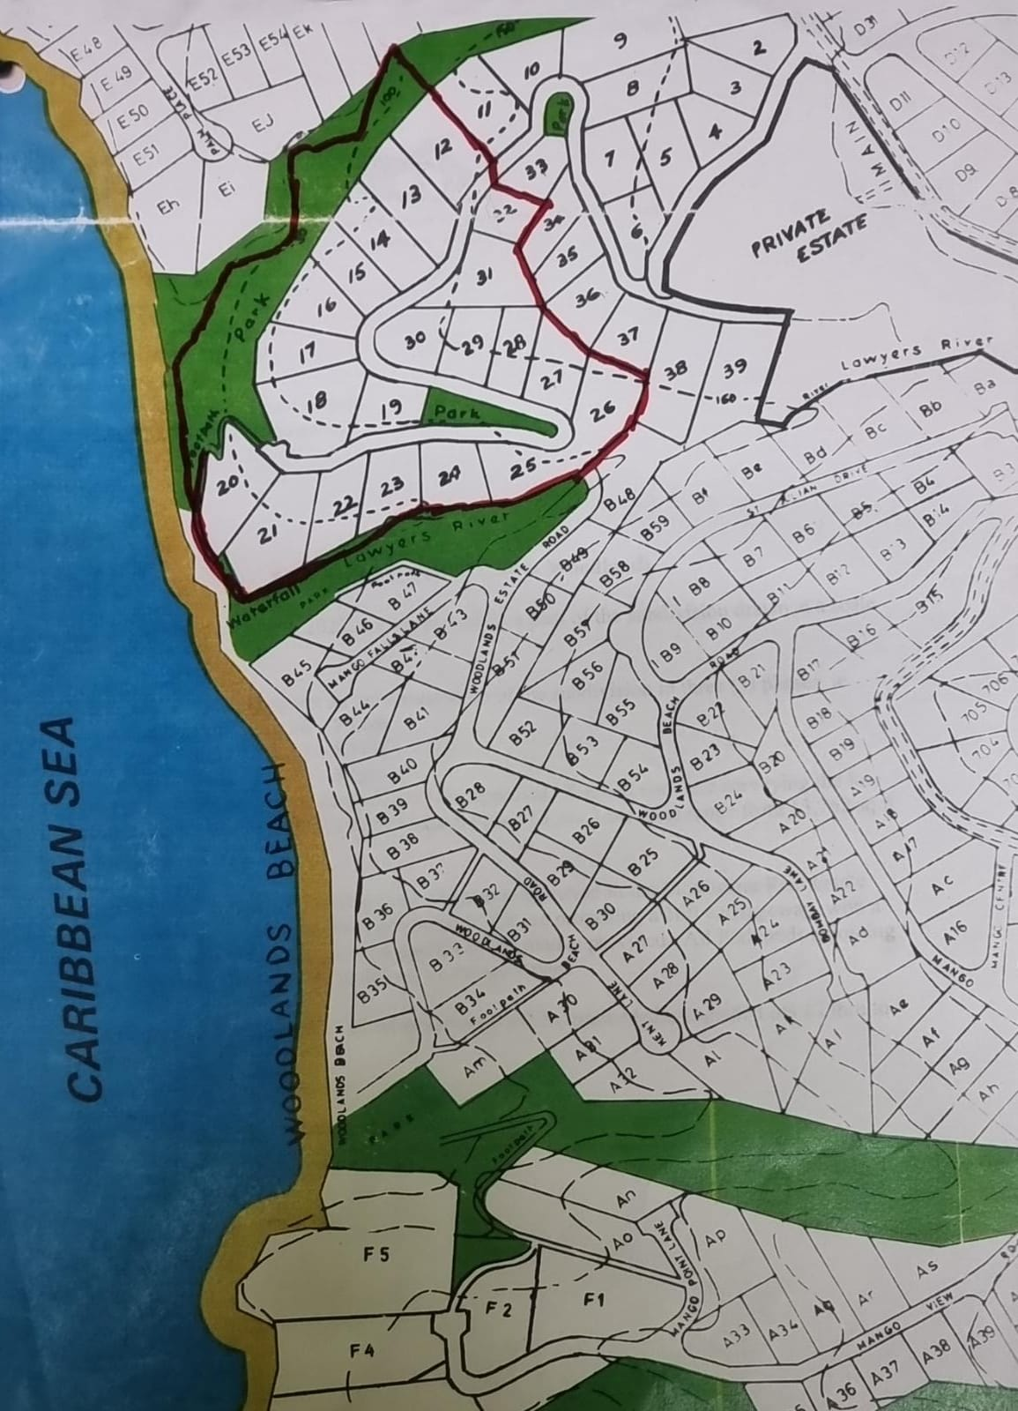

Phase 1 - Lots 26 to 32 - 7 lots
Phase 2 Lots 12 to 17 - 6 lots
Phase 3 Lots 18 to 25 - 8 lots
Note: Public access will be available via the road network. Permission will be required by the land owner to access the property of parcel 12/1/207. Restrictive Covenants for Woodlands will apply.

